Growth curve analysis (MATLAB script)

Last updated: 11.02.19 (NM)

Created: 05.02.19 (NM)

This MATLAB script takes animal weights and analyzes the amount and kinetics of growth.

For working example, follow described procedure using growthData.xlsx provided in the SOP folder.

# Procedure

1. Data must first be prepared in an appropriate input format prior to analysis in MATLAB. Prepare excel sheet with 6 columns labeled: ID, birthDate, startDate, weightDate, weight, condition (**Figure 1**)
   * **ID**: numerical value used to identify mouse
   * **birthDate**: date of birth (DD-MM-YYYY)
   * **startDate**: date of first data collection/beginning of exp. (DD-MM-YYYY)
   * **weightDate**: date of weighing (DD-MM-YYYY)
   * **weight**: mouse weight (can be replaced with any other variable of interest)
   * **condition**: categorical variable, specifies condition (e.g., M fat wt vs. M fat het)

|  |
| --- |
|  |
| **Figure 1**. Data input example |

1. Save excel sheet in same folder as ‘*growthAnalysis.m*’
2. Open ‘*growthAnalysis.m*’ in MATLAB and specify analysis parameters (**Figure 2**):
   * **File**: name of excel file with input data (e.g., ‘*growthData.xlsx*’)
   * **Sheet**: name of excel sheet where input data is stored (e.g., ‘*example*)
   * **interpInterval**: Specifies what measurement interval will be analysed
     + E.g., if input data measurements are on days 0, 1, 4, 6, 10, the script will interpolate and analyze the data according to the intervals specified.
       - If interpInterval = 1, data will be interpolated and analyzed at days 0,1,2,3,4,5,6,7,8,9,10.
       - If interpInterval = 2.5, data will be interpolated and analyzed at days 0, 2.5, 5, 7.5, 10.
   * **startDate**: specifies first day at which data will be analyzed.
     + E.g., to analyzed growth between days 0 to 140, startDate = 0.
   * **endDate**: specifies last day at which data will be analyzed.
     + E.g., to analyzed growth between days 0 to 140, endDate = 140.
   * **WeightScale**: Specifies how data is scaled
     + 1 = day 0 is baseline weight (default)
     + 2 = subtract baseline weight from all weights
     + 3 = subtract minimum weight from all weights
     + 4 = compute percent difference between weights and baseline weight
     + 5 = compute percent difference between weights and minimum weight
   * saveResults: Specifies whether results are saved to new excel file.

|  |
| --- |
|  |
| **Figure 2**. Specifying analysis parameters in MATLAB |

1. Press ‘RUN’ in MATLAB

# Outputs.

1. MATLAB will output graphical results and also save numerical results to new Excel file.
2. Results are saved to new Excel file named [File RESULTS currentTime] and stored in four sheets:
   * **ID**: ID of mice included in analysis (some might have been excluded due to range of dates included for analysis)
   * **AUC**: area under growth curve for each mouse
   * **Age**:age of each mouse included in analysis
   * **baselineWeight**: weight of each mouse at beginning of experiment.

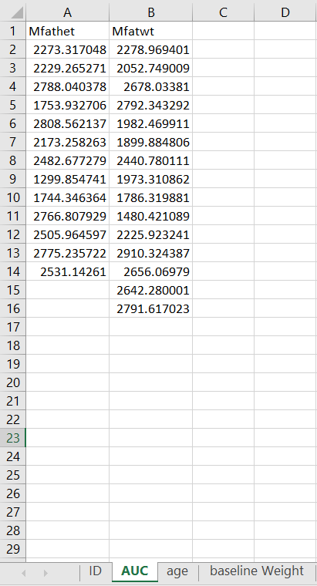

1. Graphical results include 3 figures (cage-specific activity levels, silhouette plot and descriptive statistics for each cluster):

**Raw growth curves with overlaid average**

Raw growth curve for each mouse included in analysis is displayed and stratified by condition (*grey*) and average for each condition is illustrated (*red*)

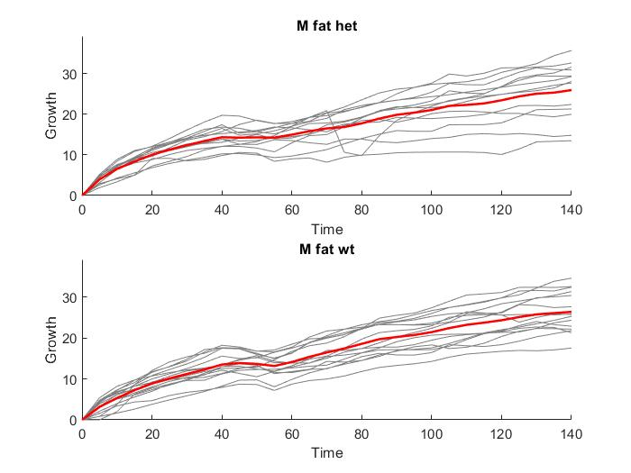

**Average growth curves**

Average growth curves ± 95% confidence interval for each condition

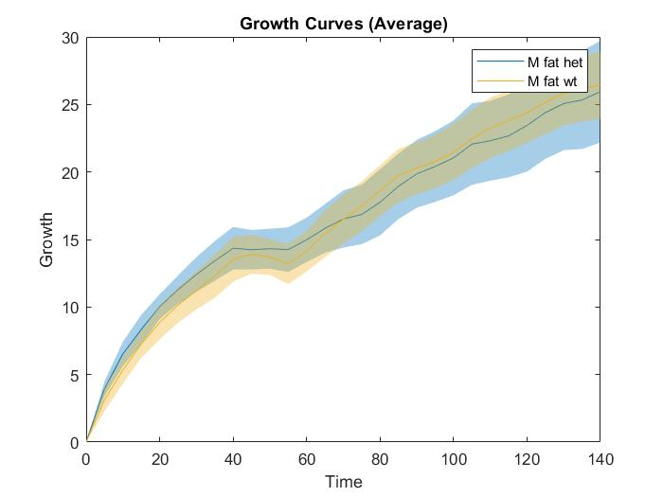

**Histogram of growth curve AUCs**

Distribution of AUCs visualized by condition

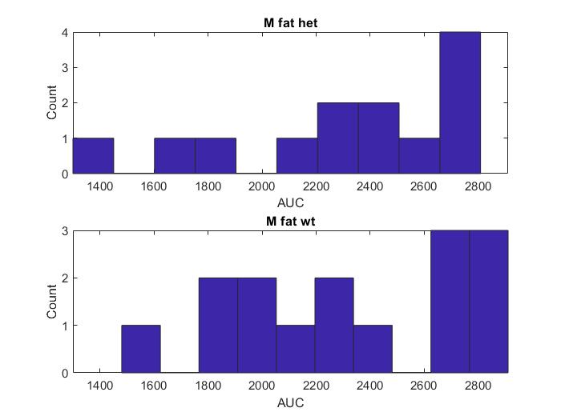

**Summary of growth curve AUCs**

Average AUC for each condition is plotted in bar plot with overall average shown (*red*)

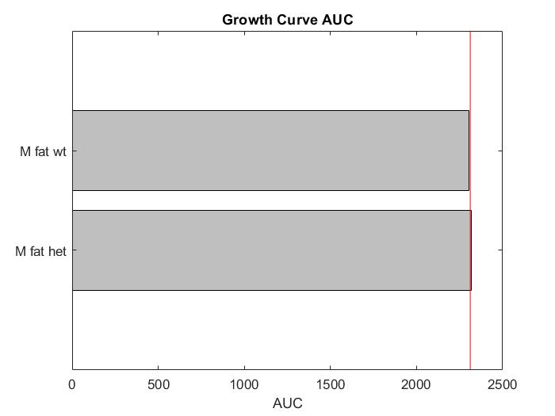

**Raw growth rate curves with overlaid average**

Raw growth rate curve for each mouse included in analysis is displayed and stratified by condition (*grey*) and average for each condition is illustrated (*red*)

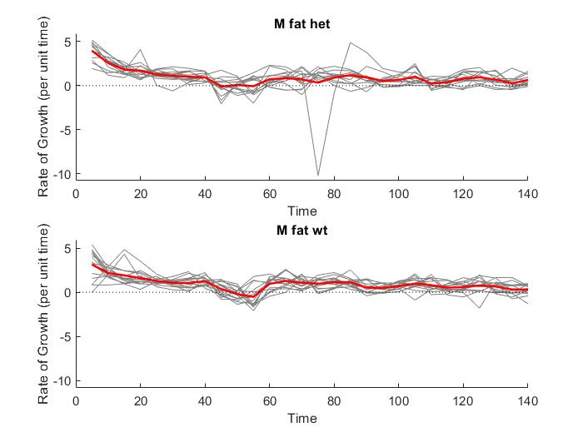

**Average growth rate curves**

Average growth curves ± 95% confidence interval for each condition

